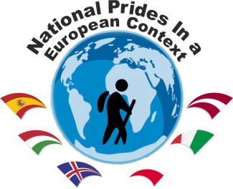 | 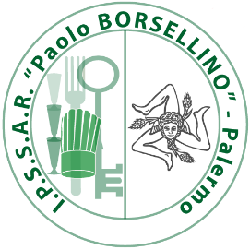  2018-1-HU01-KA229-047865_6  Venue: Istituto professionale di Stato per i servizi alberghieri e della ristorazione PAOLO BORSELLINO  Piazza Giovanni Bellissima, 3 Palermo - ITALY -  21-23 July 2021
Agenda

Wednesday  21 July 2021 |  | Thursday  22 July 2021 |  | Friday  23 July 2021
09:00 | Meeting at the school | 09:00 | Meeting at the school | 09:00 | Meeting at the school
09:30 | Presentation on the host school, Palermo, Sicily, Italian gastronomy  Maria Concetta Catalano | 09:15 | Final Report  (Continued) | 09:15 | Forming report writing teams
10:00 | Evaluation of the Eger Virtual Mobility  Ágnes Dancsok | 10:30 | Updating E-twinning project page | 10:30 | Discussion of dissemination activities  Updating Project Webpage
10:30 | Mobility Tool  Final Report | 11:00 | Implementation of the results at the schools

NOTE: Because of the Covid-19 regulations, there are no social events, such as lunch, dinner or programs together.

